Dear Parents/Guardians,
You can now purchase your child’s school supplies for Our Lady of Mount Carmel – as provided by their teacher Grade 5 – at Staples School Tools.
List ID: 459180547411804160
Grade 5
Our Lady of Mount Carmel
Ordering is easy:
- Go to Staples.ca/SchoolTools
- Click “Parents”, and search for your class byteacher, school name or city.

- Click on the correct class to see the list ofitems curated by your child’s teacher.
Discover a better way to prepare for
Back-to-School
Save up to 10% when you spend $50 or more
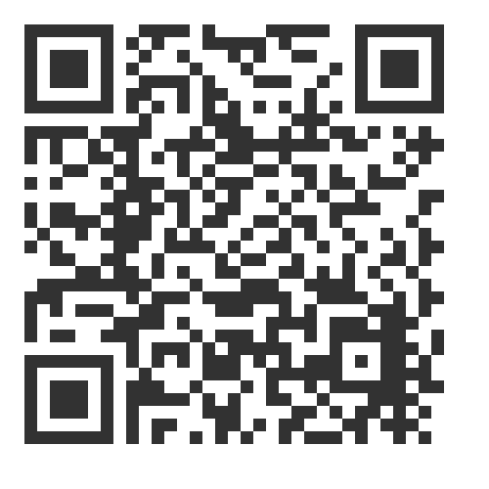
Alternatively, you can scan the QR code to directly access your teacher’s
class list. Or copy and paste the URL below into your browser.
https://www.staples.ca/pages/schooltools#parents/itemsList/45918054
7411804160
Not only will you spend less on supplies, but you’ll also be covered with a full quality guarantee and replacement warranty on everything you buy. Plus you’ll have exactly what your child needs to start the school year off right. Enjoy the total convenience of ordering from home – complete with Free Delivery.
 | Questions?
Visit our FAQs on Staples School Tools. |  | Call us at 1-877-360-8500 to speak to a representative.

